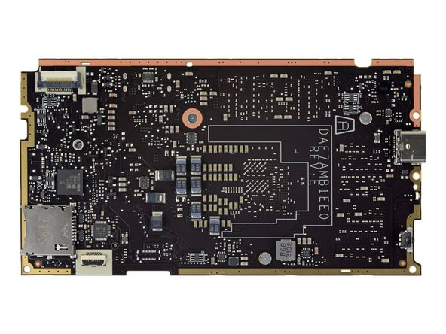 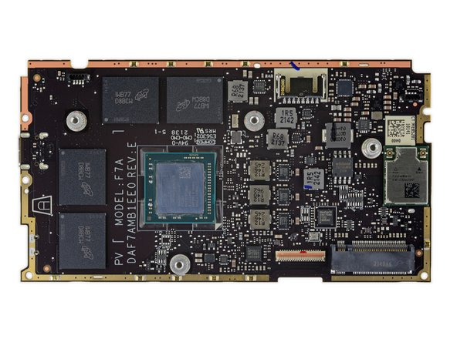





Valve’s Steamdeck

Getting some help from Ifixit, this layout should have most hardware marked..

1. Network Adapter/Internet connection - O2Micro OZ711 Card Reader Controller
2. RAM - Micron MT62F1G32D4DR-031 WT:B 4 GB LPDDR5 SDRAM Memory
3. Battery Charger - Maxim Integrated [MAX77961](https://www.maximintegrated.com/en/products/power/battery-management/MAX77961.html) USB Type-C Li-Ion Battery Charger
4. Input Device(s) - ITE Tech IT5570VG Embedded Controller (likely)
5. Output Device(s) - Analogix [ANX7580](https://www.analogix.com/en/products/dp-mipi-converters/anx7580) DisplayPort to Single MIPI Receiver
6. Flash Memory - Winbond [W25Q128JW](https://www.winbond.com/hq/product/code-storage-flash-memory/serial-nor-flash/?__locale=en&partNo=W25Q128JW) 16 MB Serial NOR FLASH Memory
7. CPU - AMD/Valve 100-000000405 Quad-Core Application Processor w/ GPU
8. MotherBoard – Steam deck Motherboard

(Shi, 2022)

Gameboy Advance

1.CPU - CPU AGB, housing the ARM7TDMI CPU

2. 256 KB WRAM

3. Input Device - Eight-way control pad

4. Output Device – Speaker

5. Motherboard

(Copetti, n.d.)

I chose to do these two devices because of the major differences nearly 20 years of advancement can do. The fact that Nintendo has labeling on the Gameboy advance (GBA) so maybe someone that does not have major hardware skills can understand where parts are when it is tore down compared to the Steam deck. The 16KB RAM on the GBA is absolutely nothing when compared to the Steam Decks 4GB of RAM!

# Works Cited

Copetti, R. (n.d.). *Game Boy Advance Architecture*. Retrieved from Copetti.

Shi, A. (2022, February 15). *Steam Deck Chip ID*. Retrieved from Ifixiit: https://www.ifixit.com/Guide/Steam+Deck+Chip+ID/147811